- Find the square root of:
- 36
Solution:
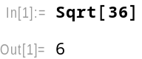

- 45
Solution:
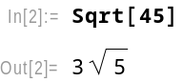

- 50
Solution:
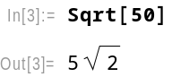

- Find the value of:
- sin$\frac{π}{3}$
Solution:
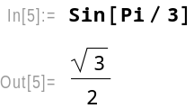

- cos$\frac{2π}{3}$
Solution:
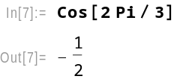

- tan$\frac{4π}{5}$
Solution:
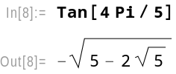

- If A= {4,5,6,9,12}, B= {2,3,4,8,9,10}, then find:
- AUB
Solution:
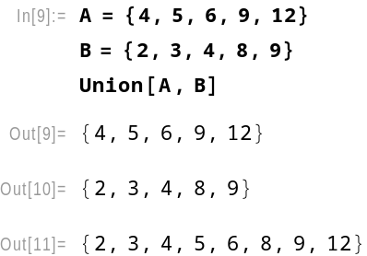
- AՈB
Solution:
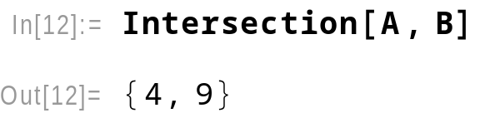

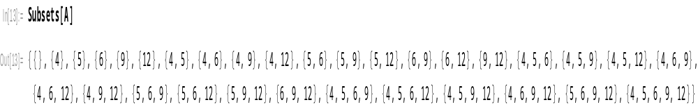
- Power set of A

- n(A)
Solution:
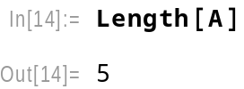

- Solve the equations:
- $x^{2}$-5x+6=0
Solution:
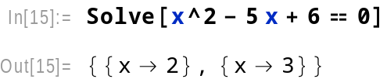

- ${5x}^{2}$- 2x+3=0
Solution:
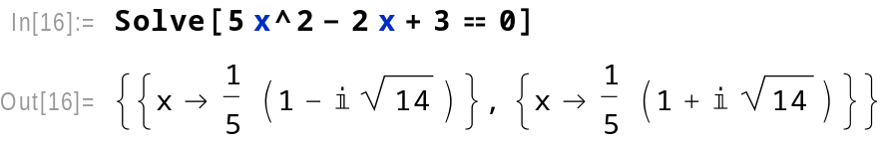

- If f(x) = 3$x^{2}$- 4 and g(x) = 3x – 1, then find:
- gof(x)
Solution:
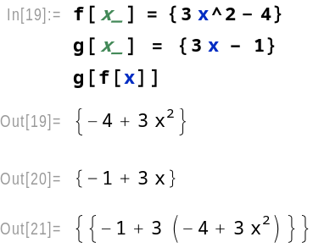
- fog(x)
Solution:
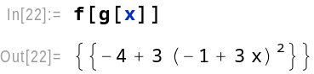

- Plot the graph of:
- f(x) = $x^{2}$
Solution:
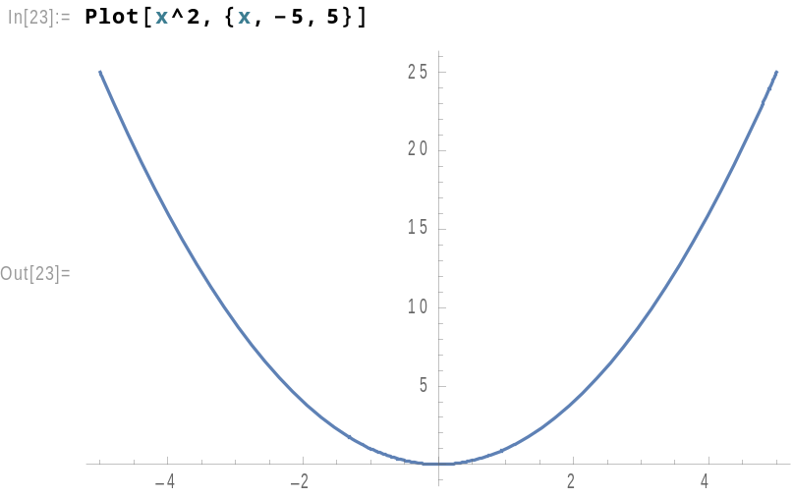

- f(x) = $x^{2}$ – 6
Solution:
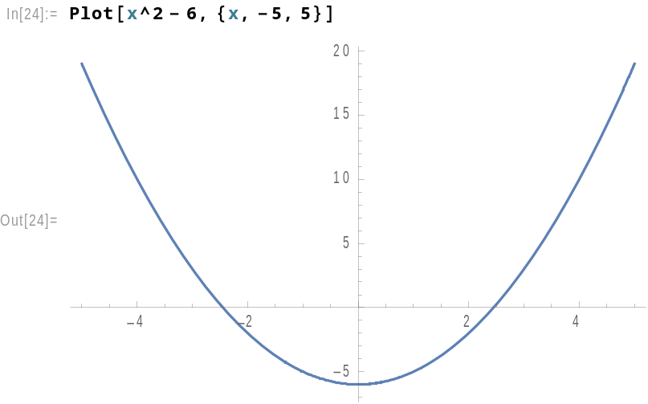

- f(x) = $x^{2}$ – 2x – 8
Solution:
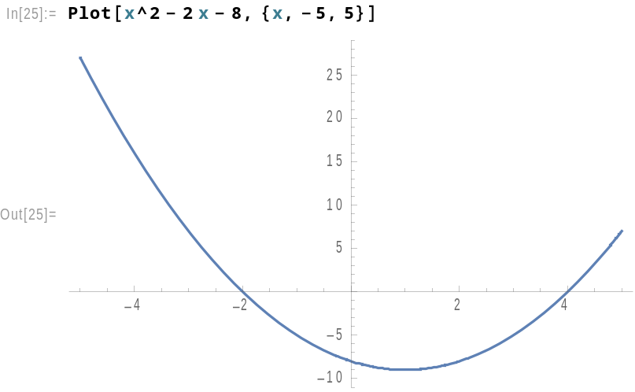

- f(x) = sinx, -2π≤x≤2π
Solution:
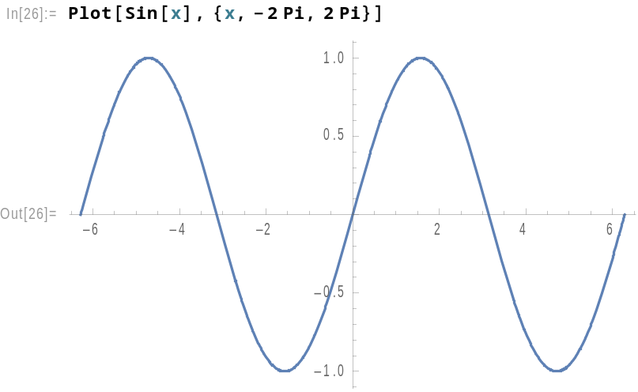

- f(x) = tanx, - $π≤x≤π$
Solution:
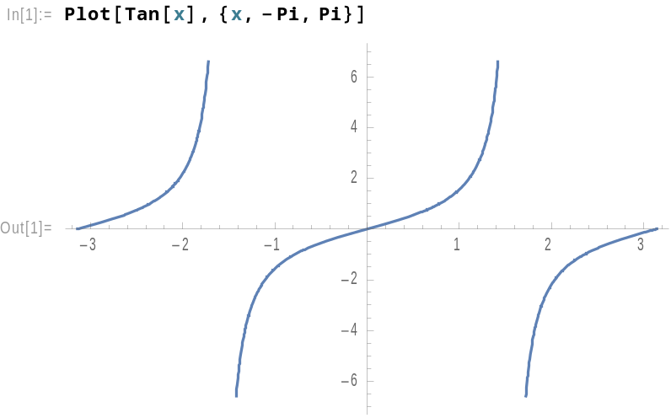

- f(x) = $e^{2x}$, - 1≤x≤1
Solution:
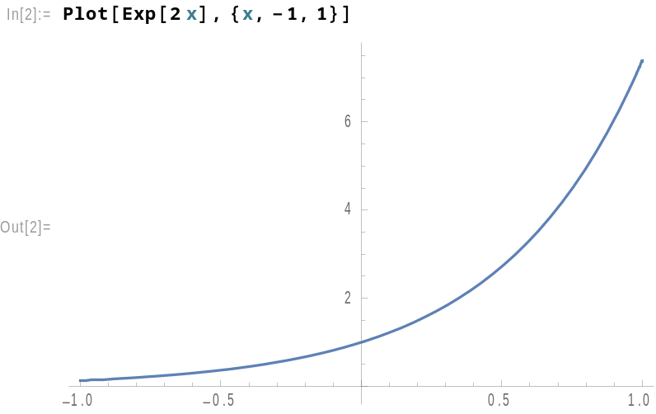

- f(x) = $\log_{4}x$, -3≤x≤3
Solution:
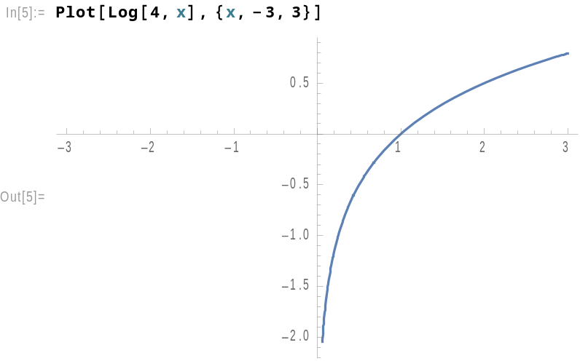

- A circle of radius 4 units and center (0,0).
Solution:
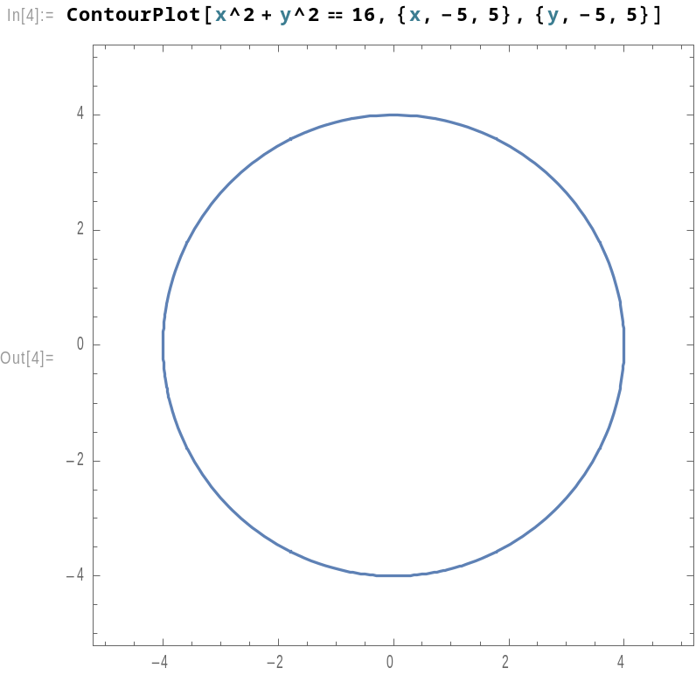

- An ellipse $\frac{x^{2}}{16}$ + $\frac{y^{2}}{9}$ = 1
Solution:
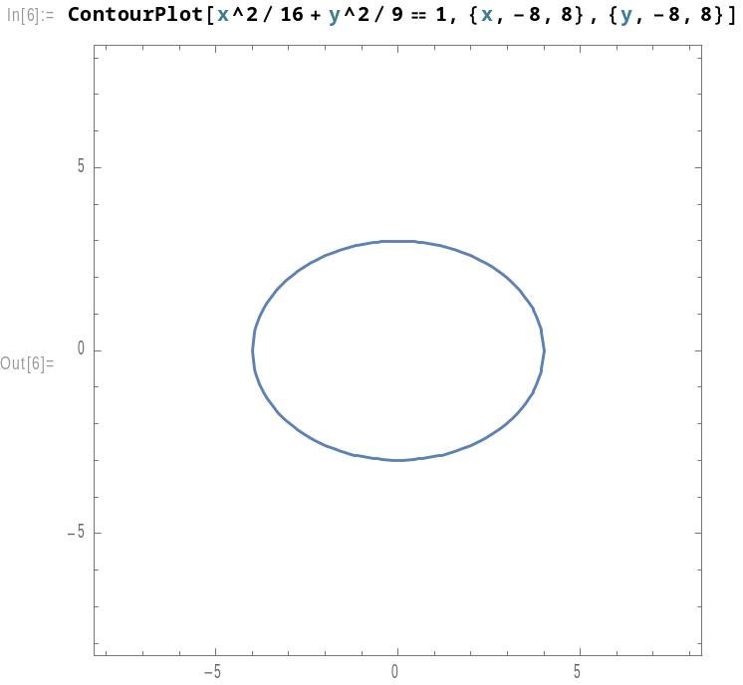
- An ellipse $\frac{x^{2}}{25}$ + $\frac{y^{2}}{36}$ = 1
Solution:

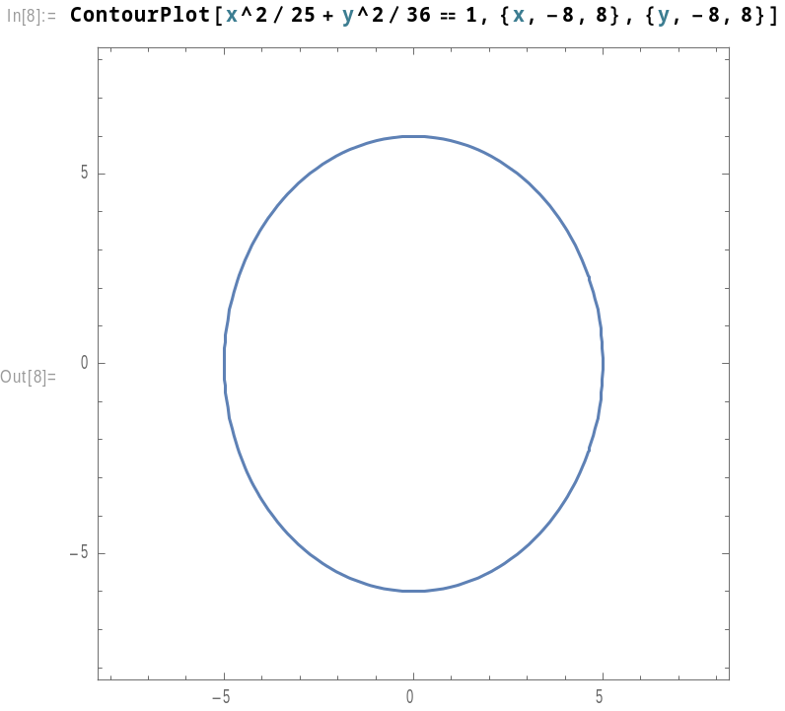
- A hyperbola $\frac{x^{2}}{25}$ - $\frac{y^{2}}{9}$ = 1
Solution:
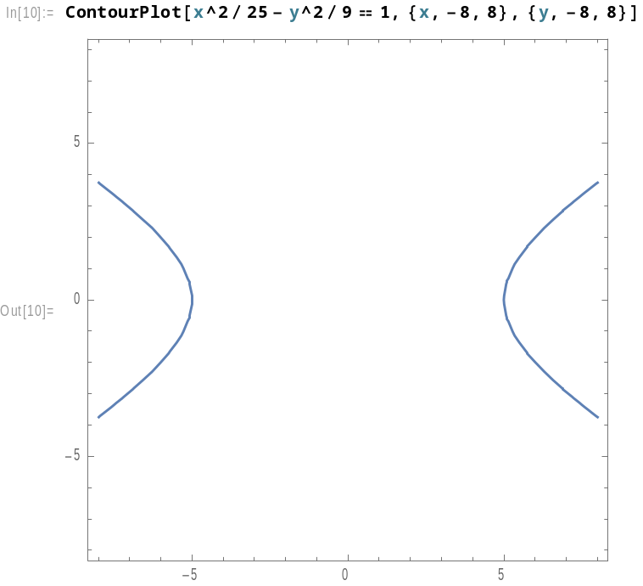

- Let A=$\left[\begin{matrix}2 & 5 & 7 \\ 0 & 4 & -9 \\ 3 & -2 & 6\end{matrix}\right]$ and B=$\left[\begin{matrix}3 & -1 & 2 \\ 8 & 0 & 5 \\ -4 & 7 & 1\end{matrix}\right]$, then find:
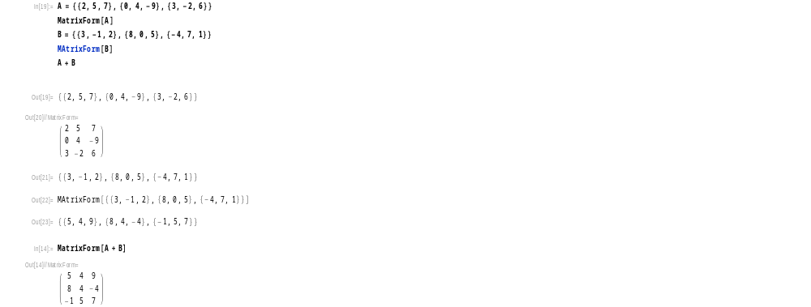
- A + B

- AB and BA]
Solution:
AB=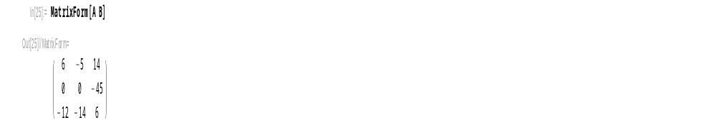
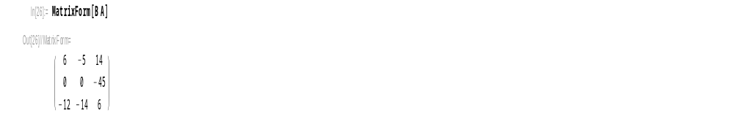
BA=

- Inverse of B
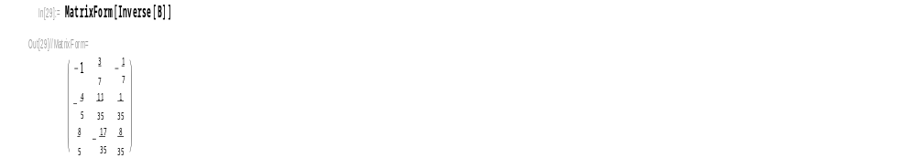
Solution:

- Rank of matrix A
Solution:
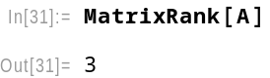

- Transpose of A
Solution:
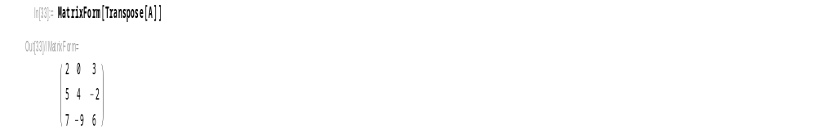

- Determinant of A
Solution:
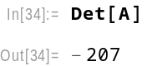

- Find the sum of the series:
- 1 + 8 + 27 + 64 + 125 + 216 + 343
Solution:
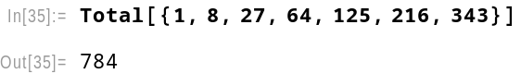

- 1 + 3 + 6 + 10 + 15 + 21 + 28
Solution:
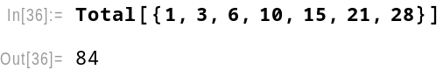

- Find the sum of:
- First 10 natural numbers.
Solution:
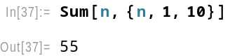

- The square of first 10 natural numbers.
Solution:
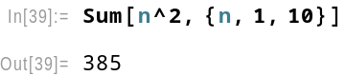

- The cube of first 10 natural numbers.
Solution:
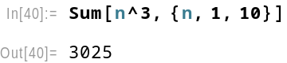

- Find the n^{th} term of the sequences:
- 2,4,6,8, …
Solution:
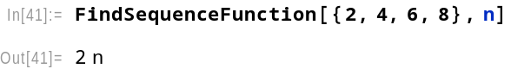

- 1.3,3.5,5.7, ….
Solution:
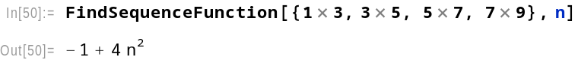

- 1,8,27,64, ….
Solution:
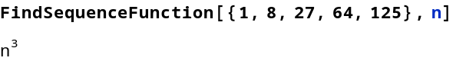

- Let $\vec{a}$ = (2,3,4) and $\vec{b}$ = (-3,6,8)
- Dot product of $\vec{a}$ and $\vec{b}$
Solution:
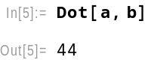

- $\vec{a}+$ $\vec{b}$
Solution:
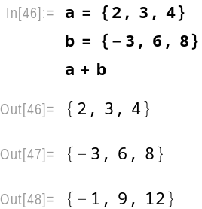

- Magnitude of $\vec{a}$.
Solution:
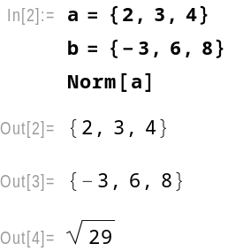

- Cross product of $\vec{a}$ and $\vec{b}.$
Solution:
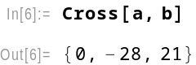

- Unit vector along $\vec{a}.$
Solution:
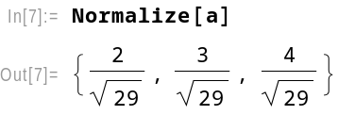

- Angle between $\vec{a}$ and $\vec{b}$.
Solution:
